“ANALYSIS & REPORTING SYSTEM OF BANK ACCOUNT DETAILS”
Case Study Documentation

21/07/2025
- Got the case study which is “Analysis & Reporting System of Bank Account Details”.
- Analyse the source file in which data is given.
- We were having only single source file, so we sorted the data.
- The source file contained various type of invalid data and errors.
- Used data preparation for cleansing the data.
- Process of Data Preparation:
- First we will go to data preparation in TMC.
- For data preparation we have to add dataset where we will write the dataset name and also add the connection which is S3/local connection.
- Upload the file from the system(local connection).
- Give format as CSV and then Validate it.
- Add preparation and select the already created dataset, then submit it.
- Some of then shows red line in data preparation so changed them as per the data type which is used.
- Some of them are showing empty cell so we entered the value as per the previous cells.
- Change the data type of BALANCE column as the integer from decimal because it will be easy to parse it.
- Manually the date format in ACCOUNT OPENING_DATE.
- Delete the unwanted blank columns.
- Now the data is clean, then select the Direct download, fill format as Excel, with the Excel 2007 and also fill the other fields also then select the environment then submit it for running.
- There were columns that were not present in the source file but they were present in the schema given to us so we created the custom columns (Data Preparation).
- Created the 10 dimension tables using the source file by denormalizing it.

22/07/2025
- Same goes when created the fact tables, there were columns that were not present in the source file but they were present in the schema given to us so we created the custom columns (Data Preparation).
- Created Fact table 1 & Fact table 2 using dimension tables.

23/07/2025
- Create a new Database connection in Talend Studio (we were getting some errors in the old one), for doing that go to Metadata in that right click on Db Connections and choose create connection.
- After creating a new connection we uploaded all of our metadata scanned flat files into our database to do that, take the newly created database as tDBOutput (Oracle with SID) and connect the metadata scanned flat file to tDBOutput component and give the necessary configurations like give table name, Action on table, Action on data.
- After putting all flat files into the database we need to retrieve those files to our talend studio, to do that right click on newly created database and in that choose retrieve schema option, a pop-up window will appear click on Next.
- In the next window click on System and there will be many files under the System checkbox, choose all the required files from there and wait for the Creation status to be success, after getting the success status click on finish and then we will get those files under table schema and we can use those files as needed.
24/07/2025
- All members created all of their respective jobs and exported their jobs as zip file and combined all of the jobs and merged all the jobs in one file, after creating one file for all jobs, we have imported them into our own systems.
- After importing the jobs into our system, we created a master job in which all of the jobs are combined together using OnSubjobOk link and we are putting all the files that we are getting from the jobs into one same folder. Because of the master job we can keep all jobs in one folder.
- Along with creating the master job we have also completed the documentation of all tasks we have completed and we have also created the presentation for the project that has been assigned to us.

SAMPLE REPORTS
1. Top ten bank accounts in terms of balance
Steps Involved:
Step 1 : Load Data i.e. Fact_Table_1 and Fact_Table_2 as tDBInput(Oracle)
Step 2 : Join Fact_Table_1 and Fact_Table_2 using tMap Component ON personal_Id column
Output fields includes personal_Id, Account_Number, Saving_Account_Balance
Step 3 : Connect to tSortRow to arrange the data in descending order
Step 4 : Use tSampleRow to fetch 10 rows
In range - Provide "1-10"
Step 5 : Use tFileOutputExcel to store output in Excel File Format
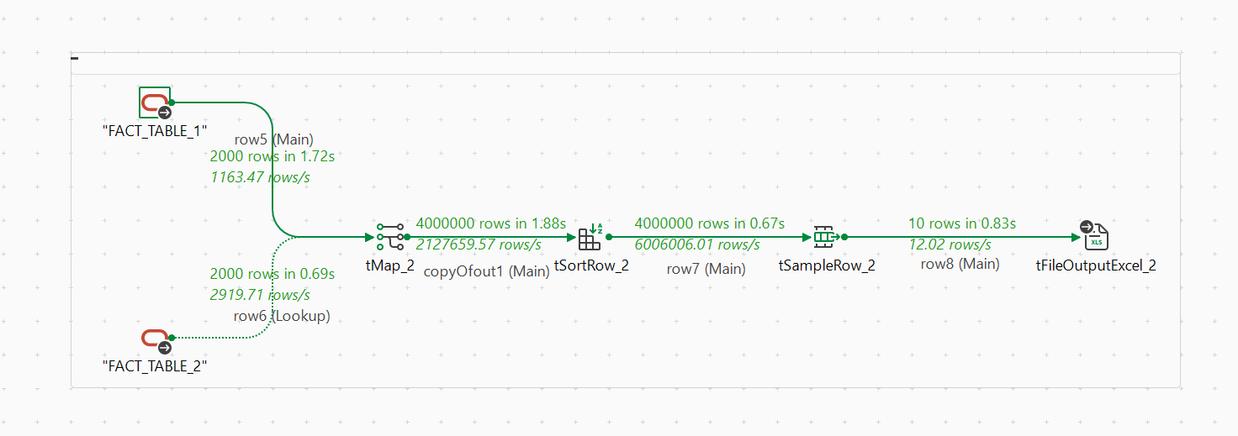Report:
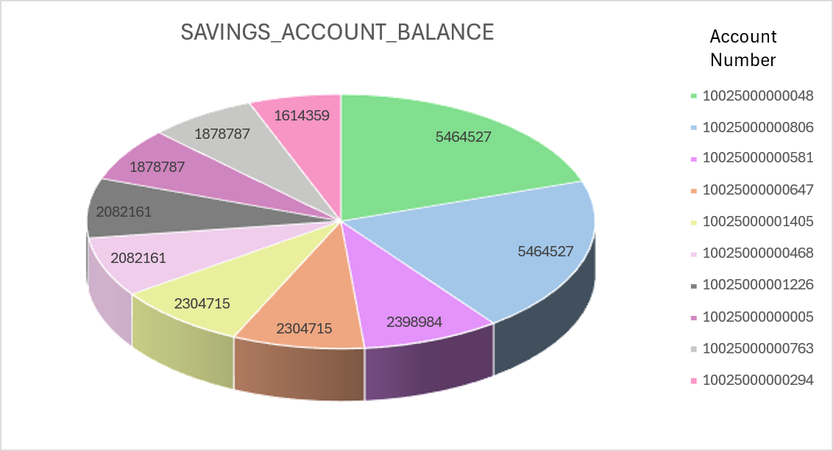

2. Analysis based on marital status and housing to provide loan
Steps Included :
Step 1 : Load data i.e. personal, fact_table_1, marital_status, loan as tDBInput(Oracle)
Step 2 : Join all the loaded tables using tMap components ON Primary_Key
Output fields includes marital_status, loan_type
Step 3 : Inside tMap , create a column for counting housing type
filter it by expression using housing=="yes"
Step 4 : Create another output table by repeating the steps 1-3 for housing=="no"
Step 5 : In both the tmap use taggregate to group by marital status and count operation by using loan_type
Step 6 : Join the Aggregated tables using tMap ON MArital_Status
Step 7 : Use tFileOutputExcel to store output in Excel File Format
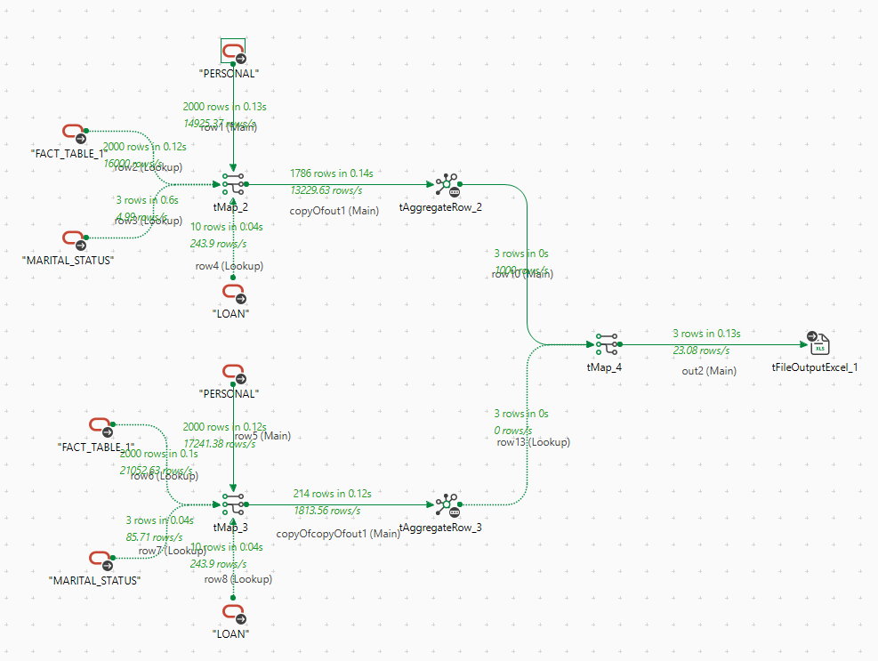

Reports:
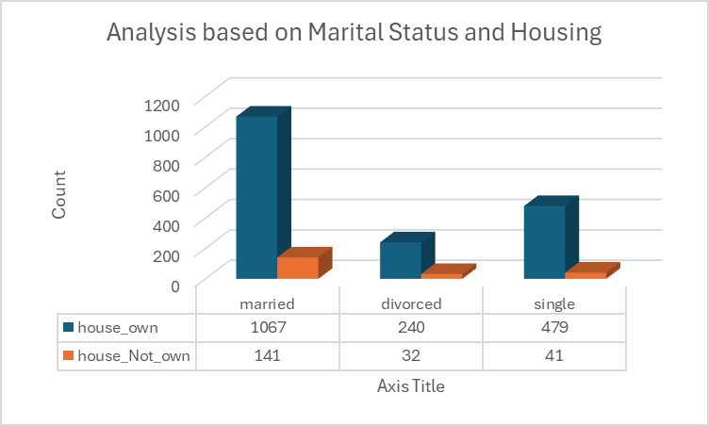

3. Analysis grouping on age and education
Steps Involved :
Step 1 : Load Data i.e. Personal and Education as tDBInput(Oracle)
Step 2 : Join Personal with Education using tMap Component ON education_Id column
Output fields include Education_Id, Education, Personal_Id
Step 3 : Inside tMap Create a new output Column : Age_Group
Use an experssion like :
(AGE <=25)? "18-25" :
(AGE <=35)? "26-35" :
(AGE <=45)? "36-45" :
(AGE <=60)? "46-60" : "60+";
Step 4 : Use tAggregateRow Component , where
GROUP BY : Age_Group, Education
OPERATION : Count
Step 5 : again Use tMap , Join Aggregated table with Education ON Education ,
output field include Education_Id, Education, Age_Group, Count
Step 6 : Use tFileOutputExcel to store output in Excel File Format.
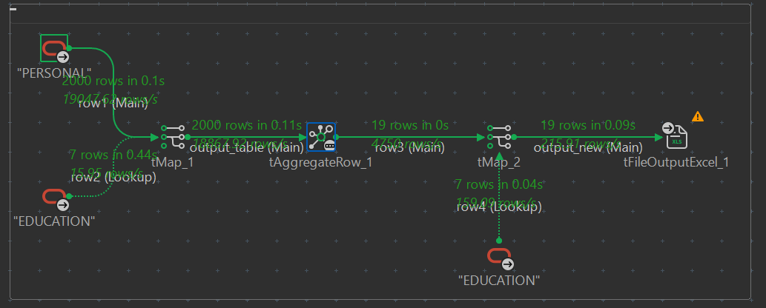Reports:
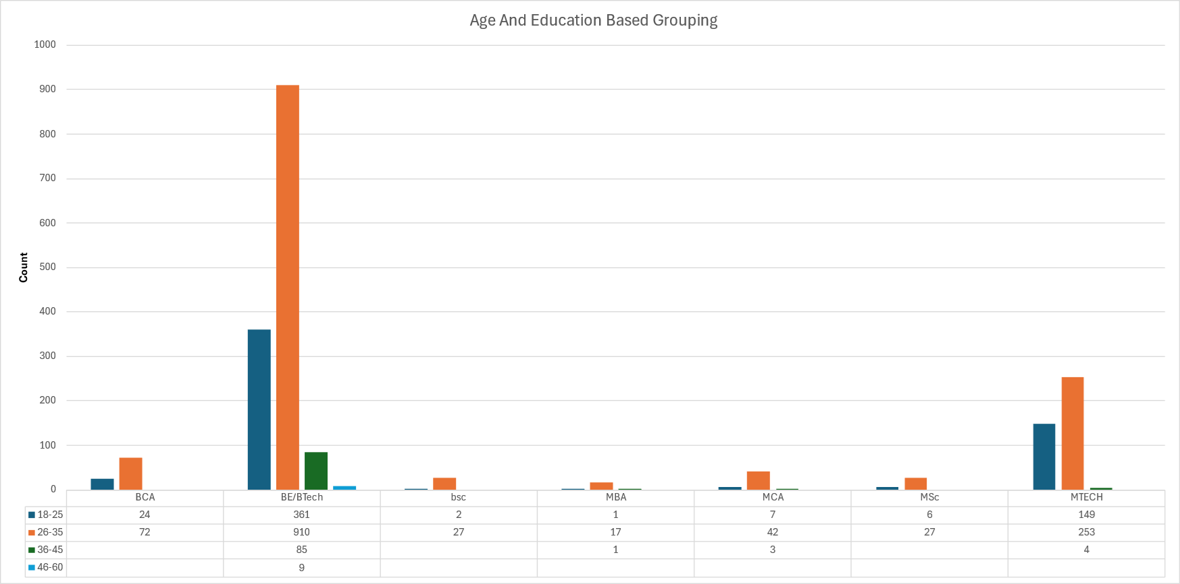

4. Based on no of account holders from the company –count of particular company
Steps Involved :
Step 1 : Load Data i.e. Fact_Table_1 and Company as tDBInput(Oracle)
Step 2 : Join Fact_Table_1 with Company using tMap component ON Company_Id column
Output fields include Company_ID, Company_name, Personal_Id
Step 3 : Use tAggregateRow Component, where
GROUP BY : Company_name
OPERATION : Count
Step 4 : Again use tMap, Join Aggregated table with Company On Company_name,
output field includes company_id, company_name, count
Step 5 : Use tFileOutputExcel to store output in Excel File Format.
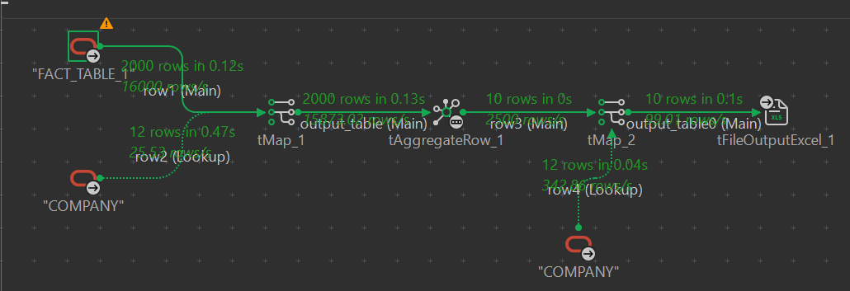
Reports:
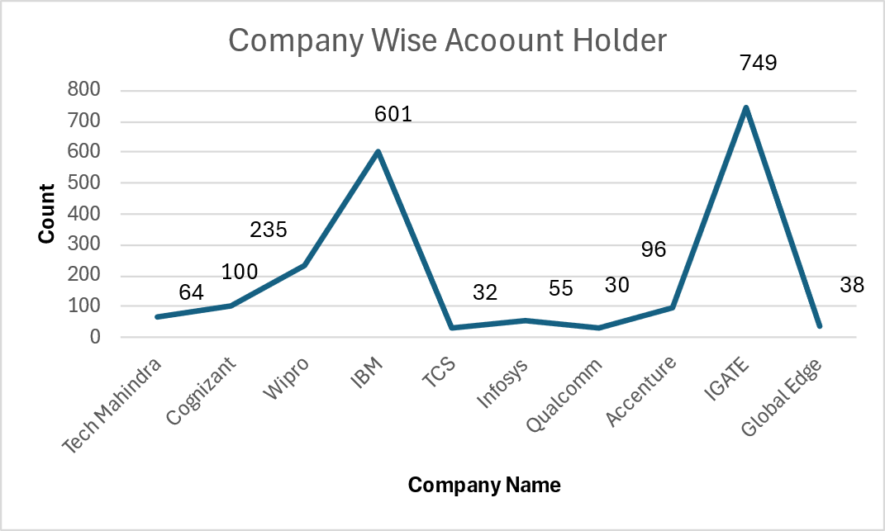

5. Based on account opening date
Steps Involved :
Step 1: Load Data i.e. Fact_Table_2 as tDBInput(Oracle)
Step 2: Join Fact_Table_2 with tMap component.
In expression of ACCOUNT_OPENING_YEAR: StringHandling.RIGHT(row1.ACCOUNT_OPENING_DATE,4)
Step 3: Use tAggregateRow Component, where
GROUP BY : ACCOUNT_OPENING_YEAR
OPERATION : Number_of_accounts
Step 4: Use tFileOutputExcel to store output in Excel File Format.
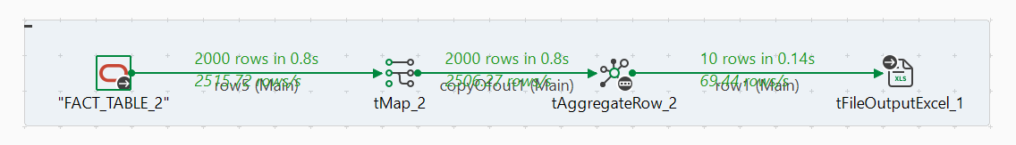Reports:
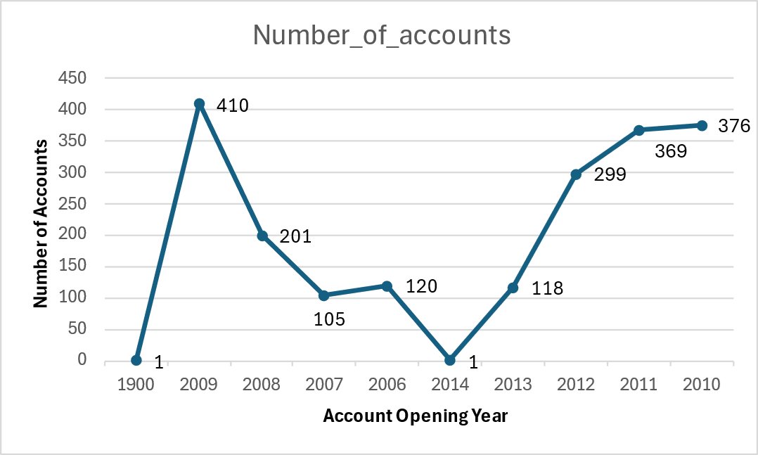

6. Based on income – income tax savings = (income-2lac) * tax%
Steps Involved:
Step 1: Load Data i.e. personal as tDBInput(Oracle)
Step 2: Join personal with tMap_1 component.
In expression of PEOPLE_COUNT: ((row1.INCOME * 12) - 200000) * 0.08
In expression of SLABS_TAX_SAVING:
(((row1.INCOME * 12) - 200000) * 0.08) <= 20000 ? "1K - 20K" :
((((row1.INCOME * 12) - 200000) * 0.08) > 20000 && (((row1.INCOME * 12) - 200000) * 0.08) <= 40000) ? "20K - 40K" :
((((row1.INCOME * 12) - 200000) * 0.08) > 40000 && (((row1.INCOME * 12) - 200000) * 0.08) <= 60000) ? "40K - 60K" :
((((row1.INCOME * 12) - 200000) * 0.08) > 60000 && (((row1.INCOME * 12) - 200000) * 0.08) <= 80000) ? "60K - 80K" :
((((row1.INCOME * 12) - 200000) * 0.08) > 80000 && (((row1.INCOME * 12) - 200000) * 0.08) <= 100000) ? "80K - 1L" :
((((row1.INCOME * 12) - 200000) * 0.08) > 100000 && (((row1.INCOME * 12) - 200000) * 0.08) <= 120000) ? "1L - 1.2L" : "1.2L - 1.4L"
Step 3: Use tAggregateRow Component, where
GROUP BY : SLABS_TAX_SAVING
OPERATION : PEOPLE_COUNT
Step 4: Create one excel file to add S.No in it and name it as slab_ranking
Step 5: Again use tMap_2 component and connect the slab_ranking to tMap_2
Step 6: Then tMap_2 is connected to tSortRow and sort it on the basis of S.No
Step 7: Use tFileOutputExcel to store output in Excel File Format and remove S.No from the schema
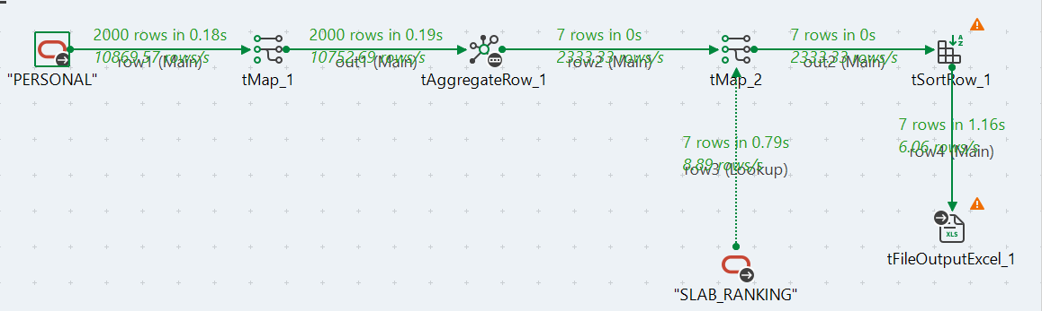
Reports:
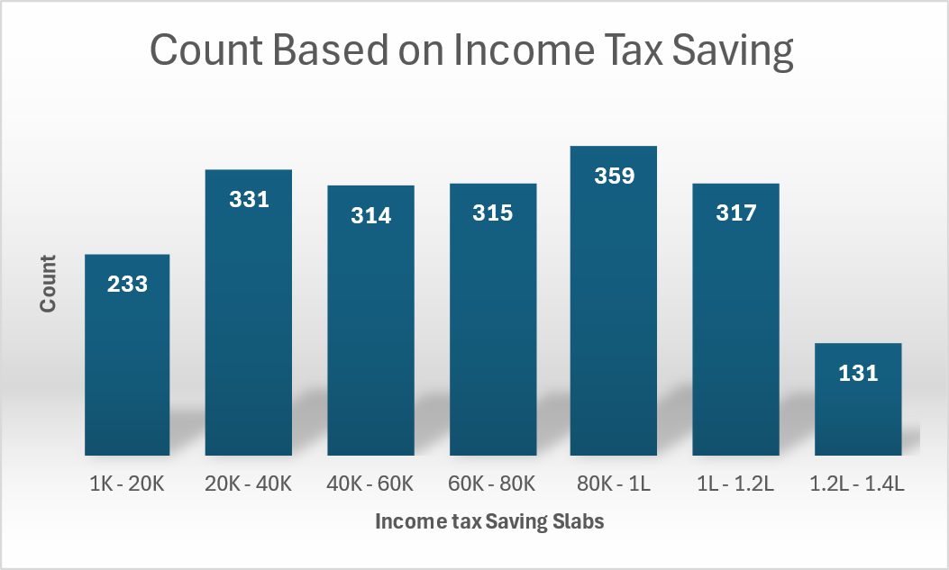

7. Based on age-retirement policies
Steps Involved :
Step 1 : Load Data i.e. Personal table as tDBInput(Oracle)
Step 2 : Use tMap component to customize the ouput
Output fields include age(renamed as people_count)
Step 3 : Inside tMap,add two additional columns ,
Age_Range ,including an expression like :
(row1.AGE >=20 && row1.AGE <40)? "20-39":"40+"
Another one is RETIREMENT_POLICIES,including an expression
(row1.AGE >=20 && row1.AGE <40)? "NOT ELIGIBLE FOR RETIREMENT BENEFITS":
"FULL RETIREMENT ELIGIBILITY WITH FULL BENEFITS
Step 4 : Use tAggregateRow Component, where
GROUP BY : Age_Range
OPERATION : Count
Step 5 : Use tFileOutputExcel to store output in Excel File Format.
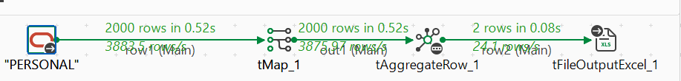
Reports:
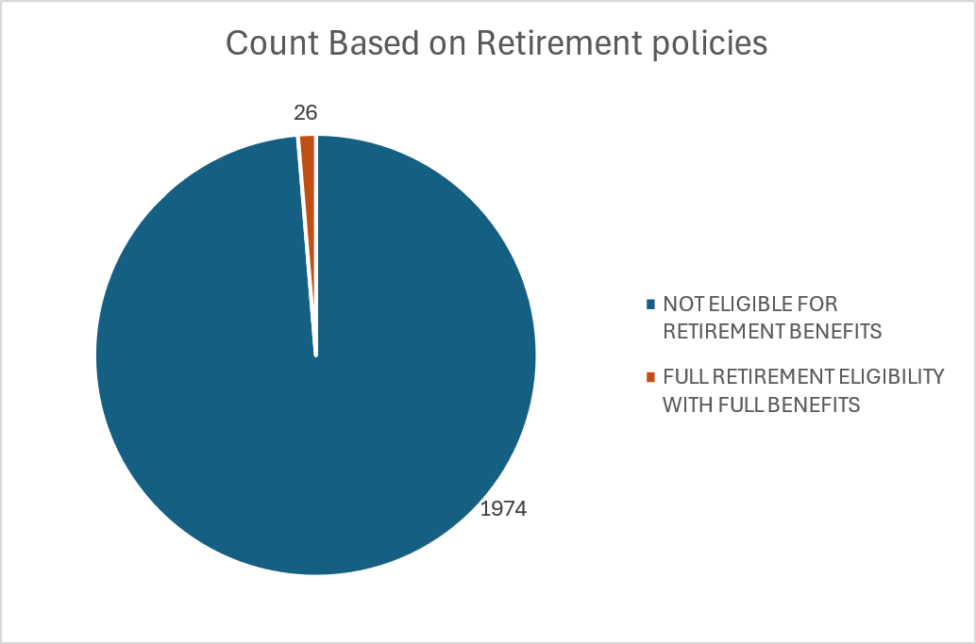

8. Based on experience – policies /offers=experience (based on their likings)
Steps Involved :
Step 1 : Load Data i.e. Fact_Table_1 as tDBInput(Oracle)
Step 2 : Use tmap for mapping the output
Output includes experience(Renamed as EXP_COUNT)
Step 3 : Inside tMap, Add two additional columns,
EXP_RANGE, including an expression
(EXPERIENCE >=0.0 && EXPERIENCE < 3.0)?"0.0-3.0":
(EXPERIENCE >=3.0 && EXPERIENCE < 6.0)?"3.0-6.0":
(EXPERIENCE >=6.0 && EXPERIENCE < 9.0)?"6.0-9.0": "9.0+"
another one is POLICIES, including an expression
(EXPERIENCE >=0.0 && EXPERIENCE < 3.0)?"STARTER KIT POLICY":
(EXPERIENCE >=3.0 && EXPERIENCE < 6.0)?"EARLY GROWTH POLICY":
(EXPERIENCE >=6.0 && EXPERIENCE < 9.0)?"PROFESSIONAL ADVANCEMENT OFFER":
"EXECUTIVE EXCELLENCE POLICY"
Step 4 : Use tAggregateRow component, where
GROUP BY : EXP_RANGE
OPERATION : Count
Had to include POLICIES column in Group by as without including it the column was giving null value.
Step 5 : Use tFileOutputExcel to store output in Excel File Format.
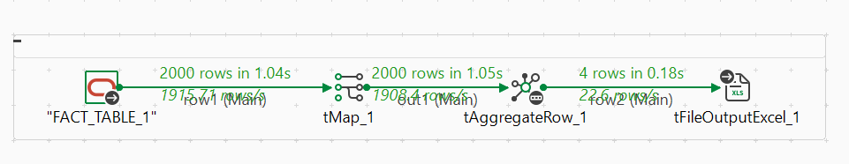

Reports:
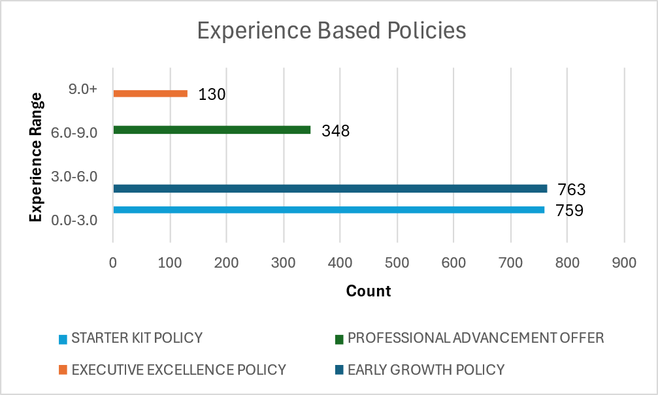

9. Based on region to establish more banking portals-count of all locations
Steps Involved:
Step 1 : Load Data tables : Fact_Table_1 and location table as tDBInput(Oracle)
Step 2 : Using tMap join both tables taking fact_table_1 as row_1 and location as row_2, join location_id from row_1 to location_id of row_2, and inside row_2 configuration choose the inner_join.
Step 3 : Inside tMap create a new output column out_1(we can rename it) and drag the row_2 columns into the out_1 and also drag the location_id of row_1 in the out_1 column.
Step 4 : Use tAggregateRow Component, where
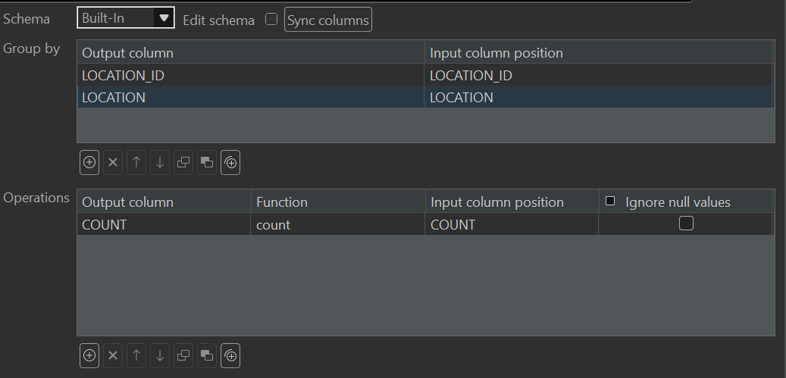
Step 5 : Use tFileOutputExcel to get the output in excel file
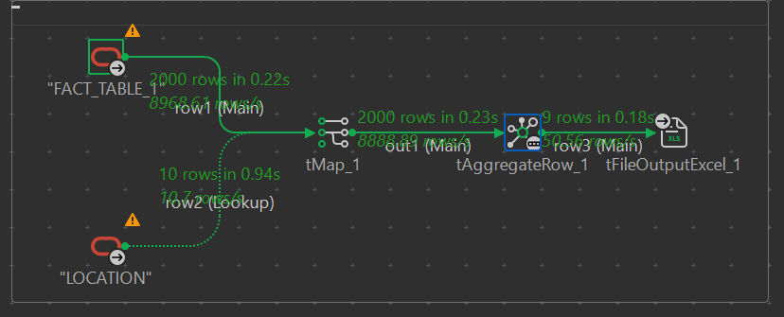Reports:
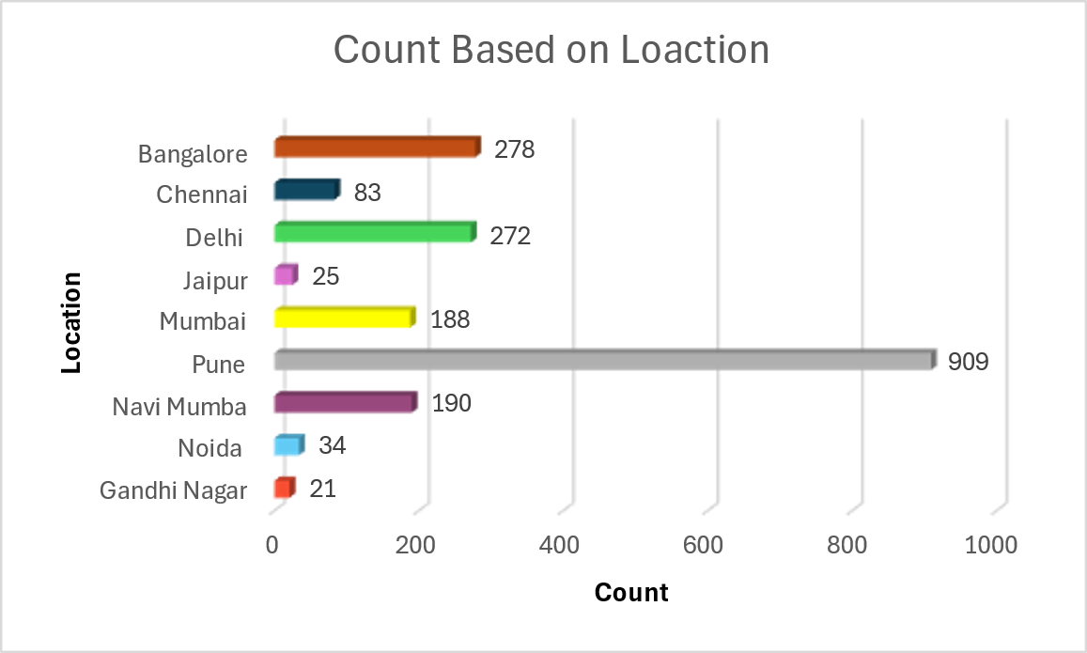

10. Based on reward points – offers
Steps Involved :
Step 1 : Load Data i.e. Fact_Table_1 as tDBInput(Oracle)
Step 2 : Use tMap_1 for mapping the output
output includes Rewards_point_range and Person_count
Step 3 : Rewards_point_range includes an expression
(row1.REWARD_POINTS<=1000 ? "0 - 1K" :
row1.REWARD_POINTS>1000 && row1.REWARD_POINTS<3000 ? "1K - 3K" :
row1.REWARD_POINTS>3000 && row1.REWARD_POINTS<5000 ? "3K - 5K" :
row1.REWARD_POINTS>5000 && row1.REWARD_POINTS<7000 ? "5K - 7K" :
row1.REWARD_POINTS>7000 && row1.REWARD_POINTS<10000 ? "7K - 10K" :
row1.REWARD_POINTS>10000 && row1.REWARD_POINTS<50000 ? "10K - 50K" :
row1.REWARD_POINTS>50000 && row1.REWARD_POINTS<100000 ? "50K - 1L" : "1L - 70L")
Step 4 : Use tAggregateRow component, where
GROUP BY : Reward_points_ra
OPERATION on Person_count : Count
Step 5 : Use tMap_2,
out_2 has following expressions
Serial_numbers, Rewards_point_range, Person_count and Offers
Serial_numbers has the following expressions
(row2.Rewards_point_range.equals("0 - 1K") ? 1:
row2.Rewards_point_range.equals("1K - 3K") ? 2 :
row2.Rewards_point_range.equals("3K - 5K") ? 3 :
row2.Rewards_point_range.equals("5K - 7K") ? 4 :
row2.Rewards_point_range.equals("7K - 10K") ? 5 :
row2.Rewards_point_range.equals("10K - 50K") ? 6 :
row2.Rewards_point_range.equals("50K - 1L") ? 7 : 8)
and Offers has the following expressions
(row2.Rewards_point_range.equals("0 - 1K") ? "1%" :
row2.Rewards_point_range.equals("1K - 3K") ? "2.5%" :
row2.Rewards_point_range.equals("3K - 5K") ? "5%" :
row2.Rewards_point_range.equals("5K - 7K") ? "7.5%" :
row2.Rewards_point_range.equals("7K - 10K") ? "10%" :
row2.Rewards_point_range.equals("10K - 50K") ? "15%" :
row2.Rewards_point_range.equals("50K - 1L") ? "20%" : "25%")
Step 6 : Use tSortRow to arrange the offers in ascending order
Step 7 : Print the file using tFileOutputExcel and remove the Serial_numbers column
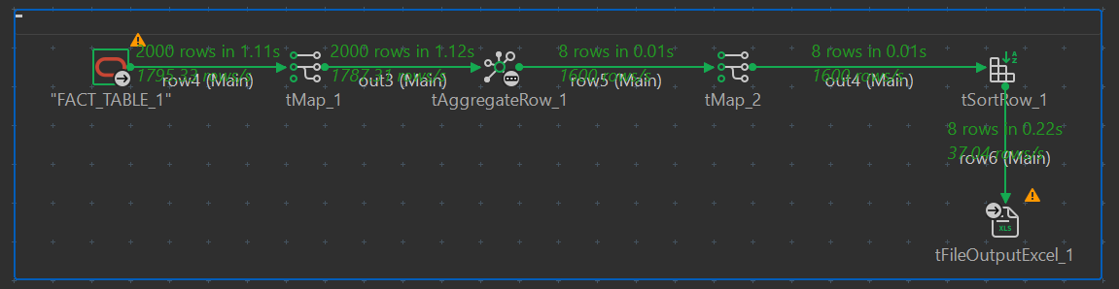Reports:
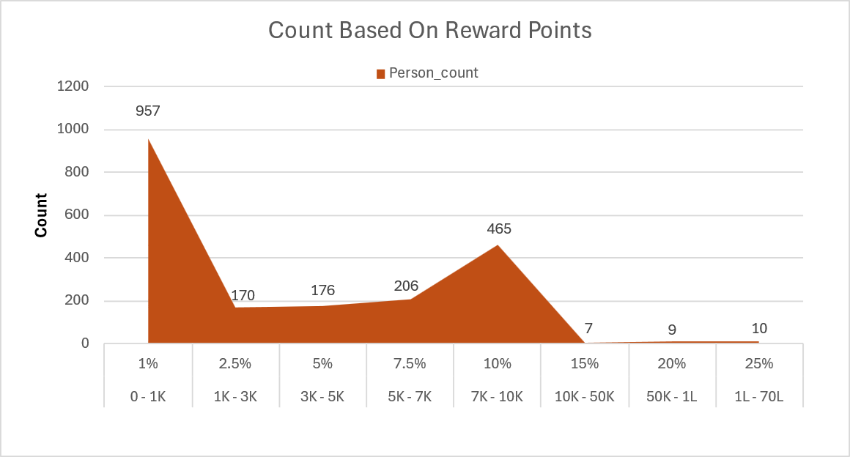

11. Number of similar types of account –count of all same types of Based on accounts
Steps Involved :
Step 1 : Load data (FACT_TABLE_2 & ACCOUNT) table using tOracleInput component. Step 2 : Group the FACT_TABLE_2 on ACCOUNT_TYPE_ID using "tAggregateRow" component and use the "count" aggregate function to count the corresponding account type.
Step 3 : Then join the output of "tAggregateRow" and "ACCOUNT" table using tMap and get the "ACCOUNT_NAME" column.
Step 4 : Save the output of "tMap" component using "tFileExcelOutput" component.
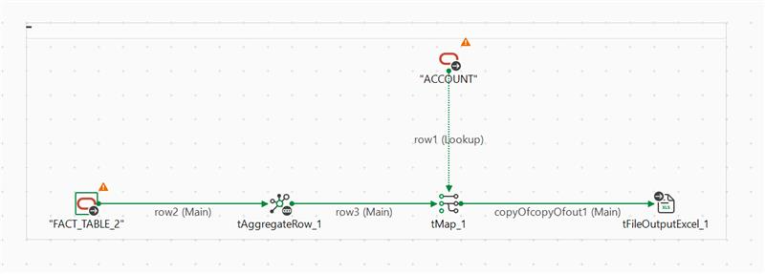Reports:
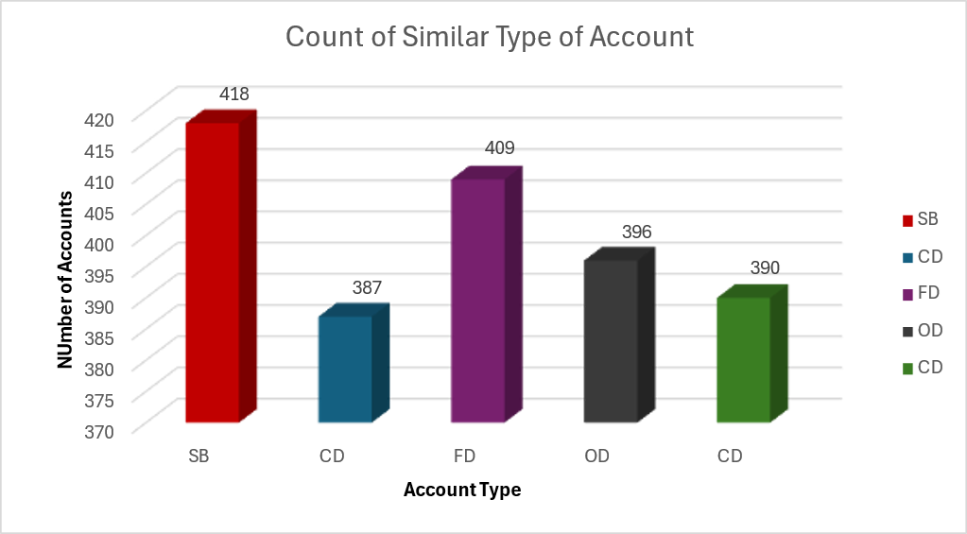

12. Based on no of similar types of loan
Steps Involved :
Step 1 : Load data (FACT_TABLE_1 & LOAN) table using tOracleInput component.
Step 2 : Group the FACT_TABLE_1 on LOAN_TYPE_ID using "tAggreateRow" component and use the "count" aggregate function to count the corresponding account type.
Step 3 : Then join the output of "tAggregateRow" and "LOAN" table using tMap and get the "LOAN_TYPE" and "RATE_OF_INTEREST" column.
Step 4 : Save the output of "tMap" component using "tFileExcelOutput" component.
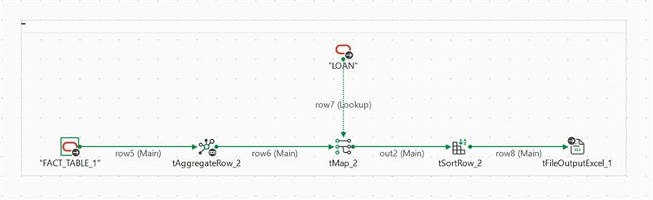Reports:
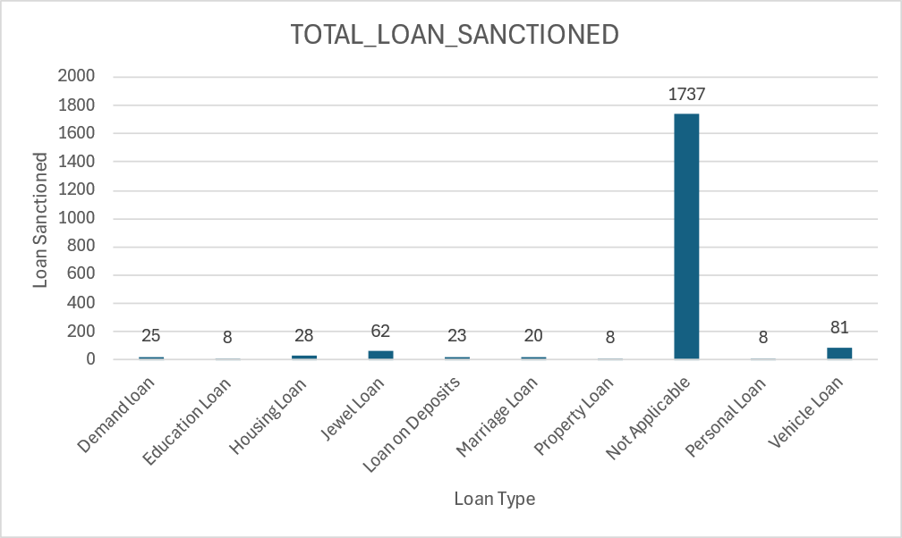
- interest rates
Step 1 : Load data (FACT_TABLE_1 & LOAN) table using tOracleInput component.
Step 2 : Group the FACT_TABLE_1 on LOAN_TYPE_ID and use the "count" aggregate function to count the corresponding account type.
Step 3 : Then join the output of "tAggregateRow" and "LOAN" table using tMap and get the "LOAN_TYPE", "LOAN_TYPE_ID" and "RATE_OF_INTEREST" column.
Step 4 : Sort the column based on "LOAN_TYPE_ID".
Step 5 : Save the output of "tMap" component using "tFileExcelOutput" component.
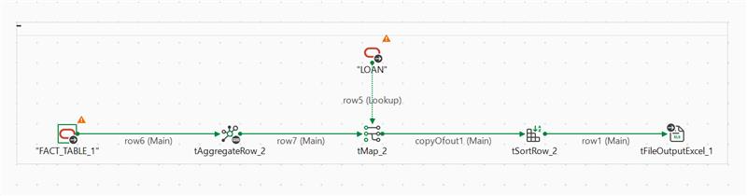Reports:
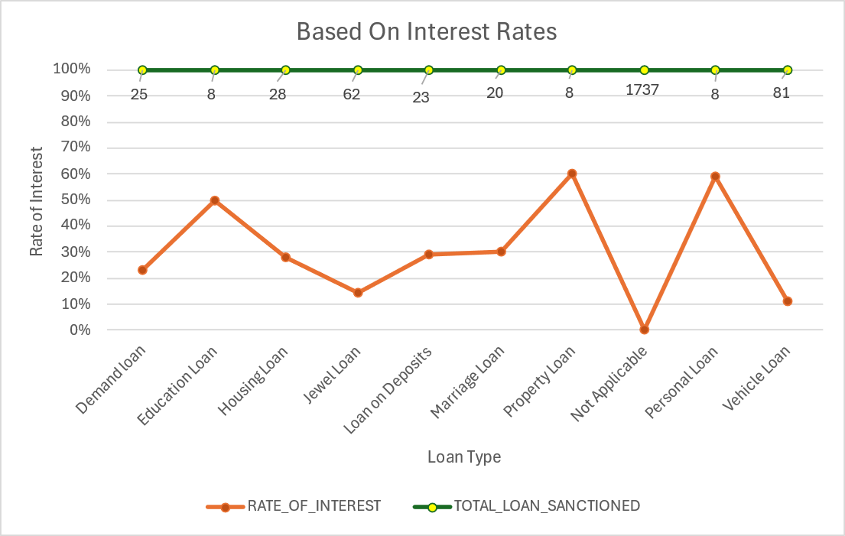
- reduction of interest rate for older accountholders=(acc opening date-current date)>some yrs a) for a specific loan type
Steps Involved :
Step 1 : Load data (FACT_TABLE_1, FACT_TABLE_2 & LOAN) tableS using tOracleInput component.
Step 2 : Using "tMap" component join the three tables using appropriate "ON" conditions.
Step 3 : In the output schema of "tMap", create custome column "Account_Age".
Step 4 : Extract the account opening year using TalendDate function and subtact it with current year.
Step 5 : Create another custom column "Reduced_Interest_Rate" and by subtracting the "INTEREST_RATE" column of loan table by 2.5.
Step 6 : Now apply the filter condition where the "ACCOUNT_AGE" should be greater than 17 and "LOAN_TYPE" should be equal to 203.
Step 7 : Save the output of "tMap" component using "tFileExcelOutput" component.
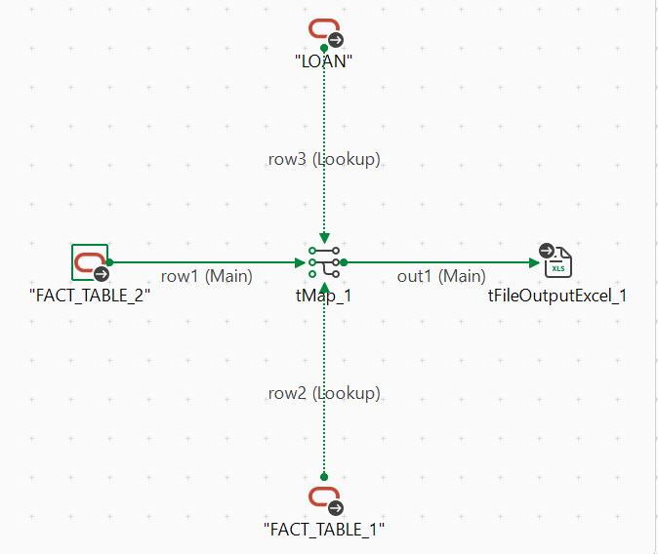
Reports:
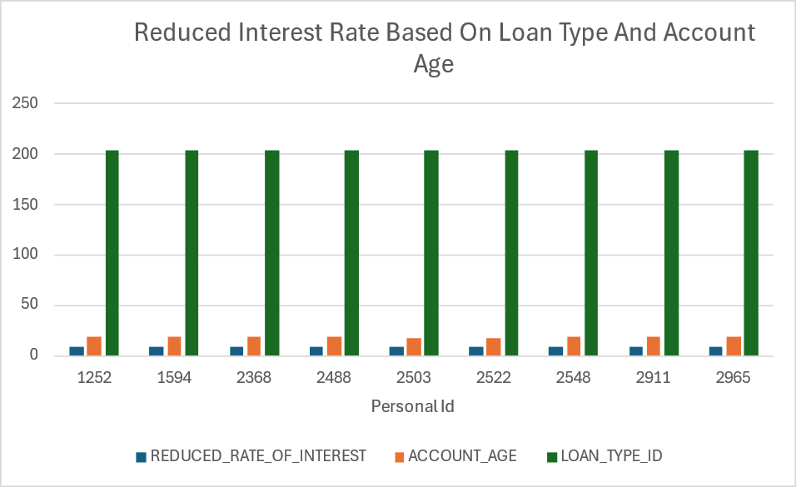

13. Based on net interest percent on the amount deposited=avg interest amount
Steps Involved :
Step 1 : Load data (FACT_TABLE_1) table using tOracleInput component.
Step 2: Link the FACT_TABLE_1 with "tMap" and create custom column "AVERAGE_INTEREST_AMOUNT", which is 7.5% of the "SAVING_ACCOUNT_BALANCE".
Step 3 : Crate another custom column "INTEREST_AMOUNT_SLAB" and assign suitable slabs according to the "AVERAGE_INTEREST_AMOUNT".
Step 4 : Group the output of "tMap" on INTEREST_AMOUNT_SLAB using "tAggregateRow" component and use the "count" aggregate function to count the number of people falling into different slabs.
Step 5 : Sort the the output by using a custom column "S_NO".
Step 6 : Save the output using "tFileExcelOutput" component.
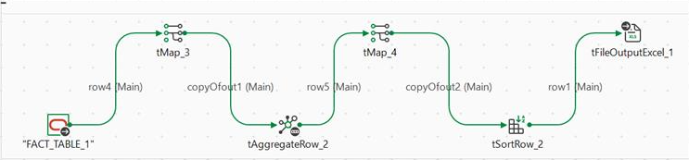
Reports:
